Rights for Time Advisory Board

Hugh Adlington
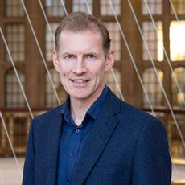
Hugh Adlington is currently a Professor at the University of Birmingham. Before coming to Birmingham in 2007, he taught at King's College London and at the University of Keele. He also held a visiting fellowship at the University of Cambridge in 2006. While at Birmingham he has held senior administrative positions in the School of English, Drama and American and Canadian Studies, as Head of Education (2011-14) and Head of Research (2016-18).
Since 2008 he has been co-convenor, first with Professor Tom Corns and latterly with Professor Sarah Knight, of the British Milton Seminar, held twice yearly in Birmingham. He is also a member of the Standing Committee of the International Milton Symposium. Between 2007 and 2012, he was the co-founder and organiser (with Dr Mary Morrissey) of the Sermons Studies Network (with over 150 scholars as members). The network held its inaugural colloquium in November 2007 on the topic of 'Uses of Secular Language in Early Modern Preaching', and two further one-day conferences at the Universities of Birmingham and Reading, on the subjects of 'Regional and Parochial Preaching' (2009), and 'King David' (2010).
https://www.birmingham.ac.uk/staff/profiles/english/adlington-hugh.aspx
h.c.adlington@bham.ac.uk
https://twitter.com/Hugh_Adlington

Nesreen Barakat
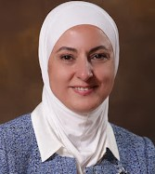
Nesreen Barakat, received a BSc. in Computer Science and Information Technology from the University of Jordan (UJ) in 1990, and an MBA from the Business School at Durham University in the UK in 1995. In 2014, she was listed as one of the Forbes 200 most powerful Arab women.

She served as the Managing Director of the National Aid Fund, before being appointed as Minister of Public Sector Development (2010-2011), and then held the portfolio of Minister of Social Development (2011- 2012).

Beyond her day-to-day work as CEO of To-Excel, Mrs. Barakat utilizes her skills and experiences to contribute to a number of organisations and important causes across Jordan. She is a member of the National Center for Human Rights Board of Trustees and a board member of the Central Bank of Jordan. Prior to that, she was a Member of the Greater Amman Municipality City Council, Economic Advisor to the Jordanian National Commission for Women (JNCW) and member of the UNWOMEN NGO Advisory Group in Jordan, the Business and Professional Women Association (BPWA), fellowship member of Vital Voices and founding member of different Associations.
https://worldscienceforum.org/participants/barakat-nesreen-35857
nesreen.barakat@to-excel.com

Paul Cooke
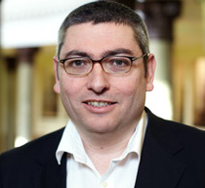
Paul Cooke is Centenary Chair of World Cinemas at the University of Leeds and specialises in the politics of representation and voice in World Cinemas. Over the last few years, he has run a number of participatory filmmaking projects supporting young people to explore the legacy of ‘difficult’ pasts. He is currently the Principal Investigator of the AHRC/GCRF Network Plus project ‘Changing the Story’. This project works across 12 countries, looking at the ways in which heritage and arts organisations support young people to help shape civil society in post-conflict settings.

He is also working with marginalised groups in South Africa and Lebanon to use film as an advocacy tool, as well as working with public health professionals to use participatory arts to develop community-led solutions to the misuse of antibiotics in Nepal. He is the director of the award-winning film The Born-Free Generation, Phendulani’s Story and Me (2018). Recent publications include, with Inés Soria Donlan (eds) Participatory Arts in International Development (London: Routledge, 2019), with Rob Stone, Stephanie Dennison and Alex Marlow-Man, The Routledge Companion to World Cinema (London: Routledge, 2018) and Soft Power, Film Culture and the BRICS Special Edition of New Cinemas, 14/1 (2017).
https://ahc.leeds.ac.uk/languages/staff/678/professor-paul-cooke
P.Cooke@leeds.ac.uk

Dr. Irene Guijt
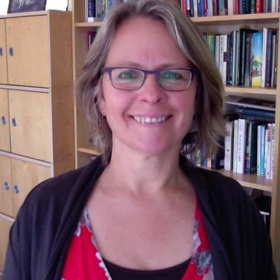
Dr. Irene Guijt has worked in rural development for 25 years, focusing on participatory processes in planning and M&E. She undertakes research, system design, facilitation and advisory work on learning-oriented knowledge processes. Recent work includes advisor for The MasterCard Foundation on how to ensure client voice is embedded in its work, testing the utility for (impact) evaluation of SenseMaker® in East Africa and Asia including on girls empowerment for GirlHub; strategic evaluation advisor for a ‘libraries for democracy’ initiative in Chile, and piloting Participatory Impact Assessment and Learning with IFAD in Vietnam. In 2000, she was team leader for researching and writing the much-used IFAD guidance on programme evaluation 'Managing for Impact'. She is a Research Associate for the Overseas Development Institute, guiding work with the Department of Foreign Affairs and Trade (Australia) to build impact evaluation examples and capacities. She is active in global evaluation capacity building through BetterEvaluation and working on theory of change for transformational development with Hivos, and in the politics of evaluation as co-convenor of the Big Push Forward, about which she is co-editing a book.
IGuijt1@oxfam.org.uk
https://twitter.com/guijti

Maria Grazia Imperiale
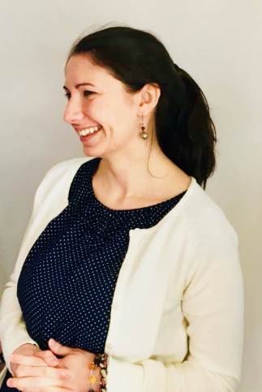
Maria Grazia Imperiale is Academic Coordinator of the Culture for Sustainable and Inclusive Peace Network Plus (University of Glasgow, School of Education) and a member of the UNESCO Chair Refugee Integration through Languages and the Arts (UNESCO RILA, University of Glasgow). She holds a Ph.D. in Language Education (University of Glasgow) and a MA(Hons) in Applied Linguistics and Intercultural Communication (University for Foreigners of Siena, Italy). Her Ph.D. thesis was entitled ‘Developing language education in the Gaza Strip: pedagogies of capability and resistance’. She has conducted research on language education, multilingualism, intercultural education in several ODA contexts, including contexts of emergencies and protracted crisis such as Palestine, Lebanon, Ethiopia, using decolonizing and participatory approaches. She teaches on different postgraduate courses within the School of Education.
https://www.gla.ac.uk/schools/education/staff/mariaimperiale/
Maria.Imperiale@glasgow.ac.uk

Stephen Hopgood
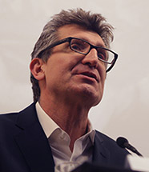
Stephen Hopgood is Emeritus Professor of International Relations at SOAS, University of London. He is the author of Keepers of the Flame: Understanding Amnesty International (Ithaca, NY: Cornell University Press, 2006) and The Endtimes of Human Rights (Ithaca, NY: Cornell University Press, 2013). He co-edited Human Rights Futures (Cambridge University Press, 2017), with Jack Snyder, and Leslie Vinjamuri, which included his chapter, “Human rights on the road to nowhere.” He is also the author of, “When the music stops: Humanitarianism in a post-Liberal world order,” Journal of Humanitarian Affairs., v1, no1, (2019), “For a fleeting moment: The short, happy life of modern humanism,” in Michael Barnett (ed.) Humanitarianism and Human Rights: A World of Differences? (Cambridge: Cambridge University Press, 2020), and “Human rights after the West: Goodbye to all that,” in Thomas G. Weiss and Rorden Wilkinson (eds.) Global Governance Futures (London: Routledge, forthcoming, 2021).
https://www.soas.ac.uk/staff/staff36174.php
https://twitter.com/stevehopgood
sh18@soas.ac.uk

Paul Jackson
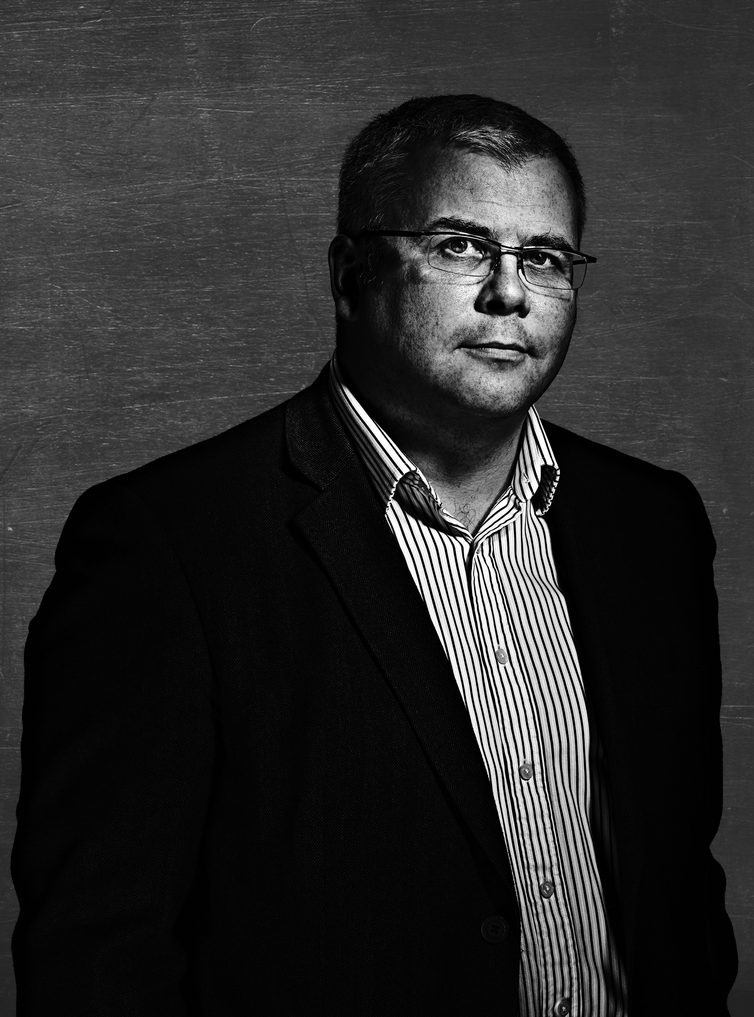
Paul Jackson is Professor of African Politics and Head of the International Development Department at the University of Birmingham. He has 25 years international experience in research, teaching and policy advice. He is currently a Senior Security and Justice Adviser for the UK Government, a member of the Folke Bernadotte Academy working group on Security Sector Reform and a member of the United Nations Copmmittee of Experts on Public Adminsitration as well as being a Commissioner to the Commonwealth Scholarships Commission. Trained as a political economist, his specialism has been governance, specifically security governance, justice and decentralisation, particularly in post-conflict or fragile environments.

He has extensive overseas experience across Africa, particularly in Sierra Leone, Ghana, Uganda and Zimbabwe, in Eastern Europe, including Romania the Czech Republic and Georgia, and South Asia, particularly Bhutan and also Nepal, where he was the international adviser to the Nepali Parliament on the integration and rehabilitation of the Maoist combatants following the war. He has worked for the UK, Danish and Swedish Governments as well as for the World Bank, the UN and EU. At the same time, he has taught for several years on governance, security and post conflict reconstruction.
https://www.birmingham.ac.uk/staff/profiles/gov/jackson-paul.aspx
https://twitter.com/jacksopb
p.b.jackson@bham.ac.uk

Keith Krause
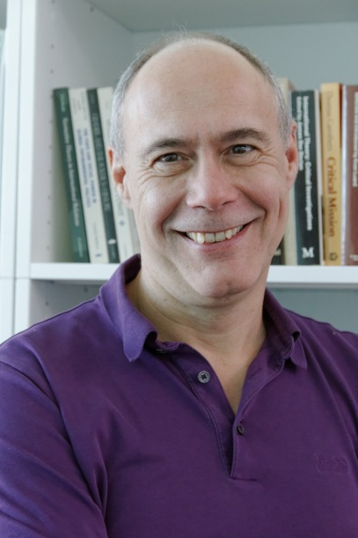
Keith Krause is Professor of International Relations at the Graduate Institute in Geneva, and Director of its Centre on Conflict, Development and Peacebuilding (CCDP). Until 2016, he was also Programme Director of the Small Arms Survey, an internationally-recognized research NGO he founded in 2001. Professor Krause obtained his D.Phil in International Relations from Balliol College, where he was a Rhodes Scholar. His research concentrates on international security and political violence, as well as post-conflict peacebuilding and security governance. He has published Arms and the State (Cambridge), edited or co-edited Critical Security Studies (Minnesota), Culture and Security, and Armed Groups and Contemporary Conflicts, as well as having authored dozens of journal articles and book chapters.
https://www.graduateinstitute.ch/academic-departments/faculty/keith-krause
Keith.krause@graduateinstitute.ch
https://twitter.com/KeithKrauseCCDP

Betty Mutesi
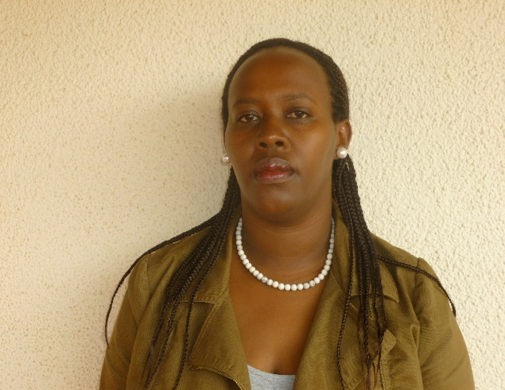
Betty Mutesi is the Country Director for International Alert for Rwanda and Burundi, and with over 16 years of experience in Peace building, Governance and Human rights. Betty holds Bachelor's in Law from University of Rwanda, a Diploma in Transitional Justice studies from University of Cape Town and Masters in Peace studies and Development from Universidad JAUME -1 of Spain.
She previously worked for the Rwanda Governance Board, Ministry of Finance and Economic planning, International Center for Transitional Justice in Cape town and International Criminal Court in the Hague.
She is the Founder and President of Hope for Rwanda organization and since 2009 she serves as Honorary Consul for the Kingdom of Spain in Rwanda.
mutesi.betty@gmail.com
https://twitter.com/bettymutesi

Agnes Odhiambo
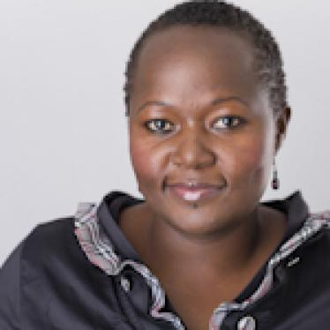
Agnes Odhiambo is a researcher with the women’s rights division of Human Rights Watch, where she investigates violations of women’s rights in sub-Saharan Africa. She currently focuses on maternal and reproductive health, violence against women, and child marriage. Since joining Human Rights Watch in 2009, Odhiambo has documented the human rights implications of obstetric fistula in Kenya, researched sexual violence affecting Somali women and girls in Kenyan refugee camps, investigated South Africa’s inadequate response to abuses against maternity patients by health workers, and documented the severe consequences of child and forced marriage in South Sudan and Malawi. Formerly, her work involved working with the media in Southern and Eastern Africa to promote women’s rights and provide a space for women’s voices, including through media monitoring, research, and training. Odhiambo has a master’s degree and a Ph.D., focusing on the impact of HIV/AIDS on the discourse of sexuality and gender, from the University of the Witwatersrand in South Africa.
https://www.hrw.org/about/people/agnes-odhiambo
odhiama@hrw.org
https://twitter.com/AgnesOdhiambo/

Rainatou Sow
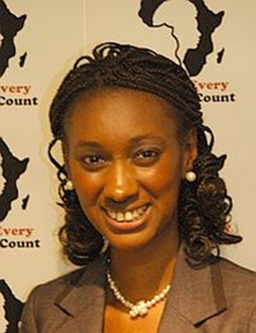
Rainatou Sow is the Founder & Executive Director of Make Every Woman Count (MEWC) which is a young African woman led organisation based in UK.

Rainatou holds an MA in International Relations as well as a MA in Law. She has worked with several organisations such as the International Organisation for Migration (IOM), World Health Organisation (WHO), UNICEF, and grassroots organizations in areas of peace, development and human rights focusing on women and youth. She has also worked at the Women’s International League for Peace & Freedom (WILPF) PeaceWomen Project on UNSCR 1325/1820 on Women Peace & Security in New York at the UN headquarters. She is an advocate of human rights, women’s issues and social justice.

Rainatou believes that Africa’s challenges will not be effectively addressed unless the exclusion faced by women and girls is tackled across the board so that they can fully participate in the economic, political & social development of the continent. She was awarded as the “Most Inspirational Woman of the Year 2012” by Women4Africa.
rai@mewc.org
https://www.mewc.org/
https://twitter.com/rainasow

